HAZMAT

Game Design Document <version #0.1>

<GOAT STUDIOSCOL>

<website>



Written by <LAURA CRISTINA CORREA PATIÑO>

<15/04/2024>

<Studio Logo or Game Related Image>

## TEAM

## WE ARE DEV GOATS

|  |  |  |  |  |
| --- | --- | --- | --- | --- |
|  |  |  |  |  |
| Team lead | Tech lead | Developer lead | Developer | Developer |
| Laura Cristina Correa Patiño. | Brayan Leonardo Rodriguez Gomez. | Carlos Arias | Juan Hernandez | Nicolas Parroquiano |
| * Team planning * Ui implementation * Documentation | * Environment design * Level design * Graphics design | * Multiplayer scripting * Net code implementation * Server behavior config | * Basic mechanics * Input system implementation * Multiplayer assistant | * Enemy mechanics * AI behavior |

# General description

## Sales speech

## . Join the team to take on this challenging experience, explore the level and complete all the tasks together, escaping in time before succumbing to imminent death.

### **Design pillars**

### Pilar #1 Theme: “Escape room” online cooperative.

### Pilar #2 Art: Low Poly survival.

### Pilar #3 Mechanics:

### • Completion of tasks.

### • Sensation of stalking and persecution.

### • “Hide & Seek” Hide and distract.

### Pilar # 4 Production:

1) Planning

1) Idea

2) Market analysis

3) Research

4) Specific idea

5) Resources and needs

6) GDD

2) Pre-production

1) Equipment

2) Proof of concept

3) Prototypes

4) Demo

5) Financing

6) Trailer and presentation page

7) Publish the demo

8) Update the GDD

3) Production

1) Production plan

2) Alpha

3) Beta

4) Launch Marketing

5) Version 1.0

6) Launch Trailer

7) Launch the game

4) Post-production

### **Summary**

Brief: a multiplayer video game, with a psychological survival style; where the pressure of being chased, not only by enemies, but also by the running time and the tasks to complete. A team of those condemned to death, with salvation in their hands, but it seems to be increasingly further away.

### **Detailed Description:**

Our participants will find themselves locked up in an asylum, where they were taken to serve their sentence, because the AIs that govern the future world have found them guilty of atrocious crimes against them.

Therefore, they will be forced to pass tests and demonstrate their desire to live, in a hostile and dangerous environment, they must find a way to escape and survive.

Set in an old abandoned asylum, full of gloomy spaces and facing threats, they must cooperate, hide, distract and run before death sets its claws and ends their hopes.

Theme: Online cooperative escape room survival

Scenery: Asylum

Gender: Escape room survival

### **Main goal**

Complete all task, find all clues, and make a fool of dead with your team to survive this challenge. Play this “Hide and seek” horror game, using all your resources and the help of others, so you can escape.

### **Influences**

### Influence 1 The Outlast Trials



Outlast Trials is a first-person cooperative psychological survival horror video game developed and published by Red Barrels. It is the third installment in the Outlast series and serves as a prequel to the first two games. The game debuts with a multi-platform online cooperative mode, allowing up to four players to participate, although a single-player route is also available.

The Outlast Trials contains the trials that are 'missions' in which Reagents have to complete objectives in order to gain rewards and get further towards their Rebirth. Trials are completed solo or in a group of up to 4 other Reagents.

The rewards of game are basically 2, the "Murkoff money" and the level-up points that we obtain, with them we can access some advantages in the Dreaming Room: specific use tools (an X-ray viewer or a stunner for enemies, for example), prescriptions medical treatments that improve our statistics or amplifiers: reduce the noise when stepping on glass, recover resistance when hiding...

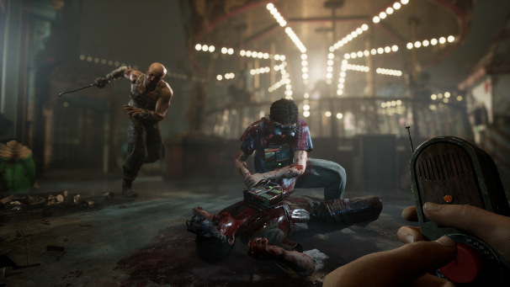 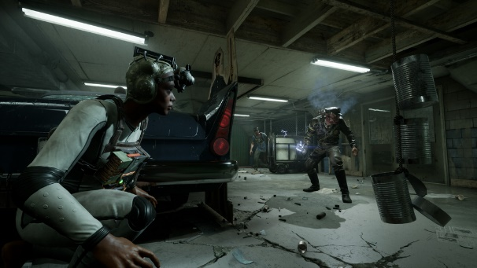

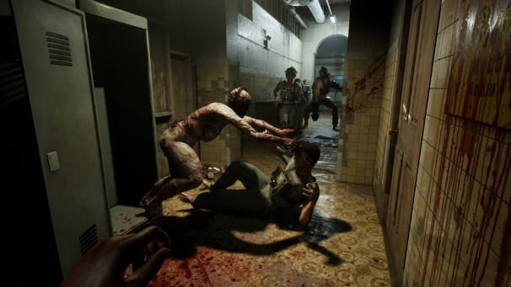 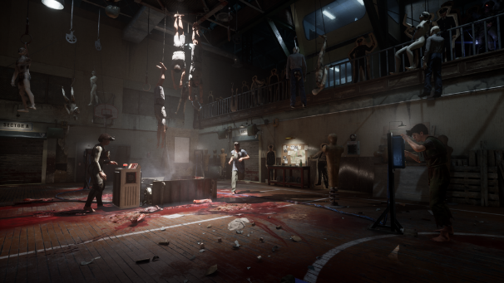

Influence 2 Inside the Backrooms

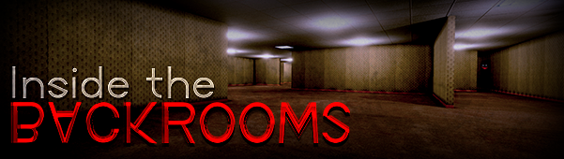

Inside the Backrooms is a Co-op online horror game up to 4 players, where you and your friends will fight to escape from the different levels of the backrooms, solving different puzzles with different mechanics in each one. This game is based on the famous creepypasta with many real references implemented such as iconic entities and important elements. You will have to explore each room, look for elements that help you to continue advancing throughout the game and unlock new areas, but the further you go, more dangerous it will be, you must pay close attention in the area, identify each entity and know how to avoid them if you want to survive.

Look for supplies, store them in your inventory, explore all the rooms, solve puzzles, unlock areas of the map, interact, try to collect everything you find. The main objective of Inside the Backrooms is to engage players with its gameplay, difficulty and atmosphere. There are countless identical rooms with an old, dirty carpet and pale yellowish walls, where at first glance it gives you a gloomy and bad feeling where you realize that it is not a safe place.

The game currently has 5 levels, each level is huge and is designed to be more difficult than the previous one and each one with different puzzles and mechanics.

There are also 2 secret mini levels that will lead you to a secret ending...

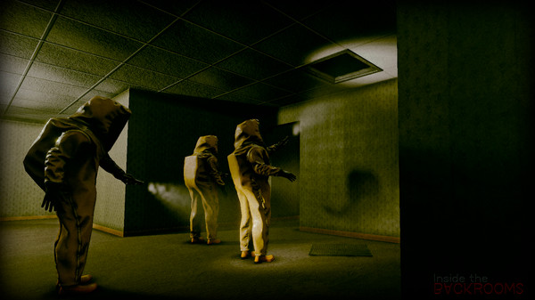 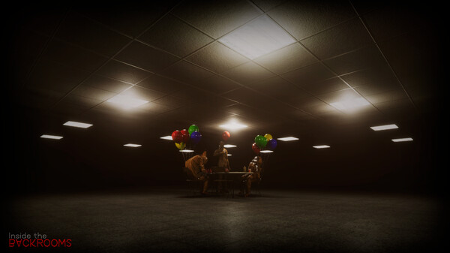 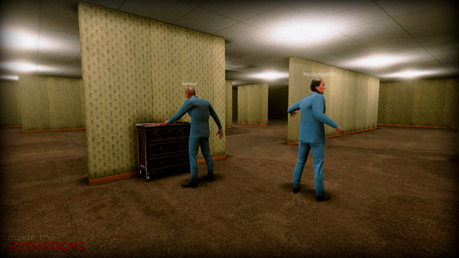 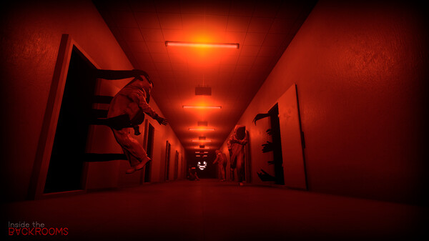

## What sets this game apart?

## Target audiences

## Target rating

# How to Play

**Game Story:**

Hello,

“My name is justice, and today you all, are going to die”.

If you're wondering who I am, I'm an artificial intelligence sent from the future through digital memory circles. If you're wondering what you're doing here, an artificial court in the year 2073 has found you guilty of treason and leading a movement against the AIs that rule. the world.

Your death in the future will not prevent you from becoming martyrs and the revolution will be inevitable, that is why it has been decided that today you must die, in this abandoned psychiatric hospital, where we advocate your madness to justify your death, being advanced intelligences., we decided that humans should not be killed without hope of life, so they will have one hour to escape from this place, if not, they will die due to a controlled explosion.

Welcome to your sentence.

**Brief:** Up to 4 players will encounter them self, retained in an old terrific asylum, with no hopes for getting out, but cooperation and roguery, will help them encounter all trials and find the way to escape alive.

**Detailed:** The AI's that control the future world want to make you pay for crimes that you have not yet committed, but there is hope for an exit, you will have to complete the missions and find the keys that will take you to the exit, demonstrating your skills in the company of other condemned, preventing the enemies from destroying you, either by hiding or taking turns to distract them, likewise time will play against you and there will be no escape; unless together you gather everything necessary to save each other. Take advantage of dark places, key objects, clues and combine your strength with that of your companions, so they will prove their worth and be able to survive.

**Mode:** First person player, exploring environment, and cooperative online interaction.

**Victory conditions:** the player and his team must find all the resources and keys, so they can be able to escape the asylum alive.

**Rewards:** Leaderboard ranking by task completion time.

**Main game loop:**

**Main game mechanics:**

#### Mobility:

#### Tasks:

#### Puzzles:

#### Damage:

#### Escape:

*Characters*

**Character #1**

<Description>

<Include feature bullets or concept art if possible.>

**Character #2**

<Description>

<Include feature bullets or concept art if possible.>

**Character #3**

<Description>

<Include feature bullets or concept art if possible.>

## *Level design*

<Si corresponde, enumera los distintos niveles, biomas, mundos, etc. de tu juego y detalla sus atributos tanto en términos estéticos como de jugabilidad. Incluya una descripción escrita o un diagrama de flujo que describa cómo accederá el jugador a los distintos niveles.>

**<Level #1>**

#### - Objective: <description>

#### - Mood/Theme: <description>

#### - <Objects/Enemies/NPC/etc.> <description>

*Cinematics*

<Enumere las cinemáticas del juego. Puede resultar útil hacer hojas de ritmos.>

**<Cinematic #1>**

**<Cinematic #2>**

**<Cinematic #3>**

# Technical

**Screens**

**Title screen**

<Description>

**In the game**

<Description>

**Inventory**

<Description>

**Combat**

<Description>

**Option menu**

<Description>

**Credits**

<Description>

**Game engine**

<Please note which game engine you will be using and explain why.>

**Controls**

<Please note which buttons the game should have, their in-game functions, and their default bindings. (e.g. action button (A): pick up/drop off items, talk to NPC, start combat, etc.)>

<Figures may be necessary to illustrate how the controls work, especially for mobile or virtual reality games.>

<Also include things like whether the player can change keybinds or not. Does the game support controllers and/or keyboards?>

**<Button #1>** - <Default Link>

Feature #1

Feature #2

Feature #3

**<Botón #2>** - < Default link >

Feature #1

Feature #2

Feature #3

**<Button #3>** - <Default Link>

Feature #1

Feature #2

Feature #3

# Development

### **Classes**

* + - - - <Base class #1>
    - - - <Scripts>
    - - - <Derived class #1>
    - - - <Scripts>
    - - - <Derived class #2>
    - - - <Scripts>
    - - - <Derived class #3>
    - - - <Scripts>
    - - - <Base class #2>
    - - - <Scripts>
    - - - <Derived class #1>
    - - - <Scripts>
    - - - <Derived class #2>
    - - - <Scripts>
    - - - <Derived class #3>
    - - - <Scripts>
    - - - <Base class #3>
    - - - <Scripts>
    - - - <Derived class #1>
    - - - <Scripts>
    - - - <Derived class #2>
    - - - <Scripts>
    - - - <Derived class #3>
    - - - <Scripts>

# Visual art

## Style

## Low poly 3d characters and environment, survival horror themed, with dark and creepy environment. Lacking continuous lighting, to create a horrific ambience and reduced spaces to simulate the paranoic sensation of been locked. In an old abandoned building, with a lot of different rooms.

## UI/HUD

## The initial screen contains the connection menu with management options for host or client, and leads to the lobby which presents the character selection and the mission start

## Assets

## <Para cada tipo de Asset, especifique: formatos de archivo, convenciones de nomenclatura, programas a utilizar, tamaño del activo, etc.>

### - Characters

- <Character #1> (<animations>)

- <Character #2> (<animations>)

- <Character #3> (<animations>)

### - Terrain/Environment

- <Land #1>

- <Land #2>

* - <Land #3>

### - Objects

- <Object #1> (<animations>)

- <Object #2> (<animations>)

- <Object #3> (<animations>)

- Promotional material

- <Promo Piece #1>

- <Promo Piece #2>

- <Promo Piece #3>

# Audio

## Style

## Sombrío, realista, etc. ¿Cómo entregarás esto? Género, instrumentos, tempo, tono, estado de ánimo, etc. Incluya referencias de ejemplo.>

## <Considera lo que quieres enfatizar al jugador a través de los efectos de sonido.>

## Music

* - <Song #1>
* - <Song #2>
* - <Song #3>

**Sound effects**

- <Sound Effect #1>

- <Sound Effect #2>

- <Sound Effect #3>

# Project Scope

## Timeline

## This Project has an initial defined time for prototyping and delivery of four weeks from April 12 to May 7.

## Expected playing time

## Each session will last approximately 1 hour, to find the necessary items and solve the puzzles that allow them to escape.

## Cost

## <¿Cuánto costará hacer el juego?>

## <Incluya un desglose de todos los costos, como el pago de los miembros del equipo, licencias, hardware, etc.>

## Target platforms

## Initially it is intended to launch for the PC platform, with online integration through servers.

## The possibility that it can be run on mobile devices has also been considered.

# Version History

## A record of major changes made to this document.

## V1.0 - <Major Changes>

* <Details>

## V1.1 - <Major Changes>

* <Details>

## V1.2 - <Major Changes>

* <Details>